Question 1 Report
Title -1
Analysis of Recursive Algorithm Using the Substitution Method

Aim
To solve the recurrence relation T(n) = T(n − 1) + n using the substitution method, implement the recursive algorithm in Python, and analyze its time and space complexity.

Problem Statement
A social media platform processes posts using the recursive algorithm:
$$T\left(n\right)=T\left(n-1\right)+n$$
Solve the recurrence using the substitution method, derive the final complexity, and analyze the algorithm using asymptotic notation.

Algorithm
- Start.
- Read the value of n.
- If n = 1, return 1.
- Otherwise, recursively call the function with n − 1.
- Add the current value of n to the recursive result.
- Display the total processing cost.
- Stop.

Python Program
def social_media_processing(n):
if n == 1:
return 1
return social_media_processing(n - 1) + n

n = int(input("Enter number of posts: "))

result = social_media_processing(n)

print("Total Processing Cost =", result)

Input
5

Output
Enter number of posts: 5
Total Processing Cost = 15

ScreenShot
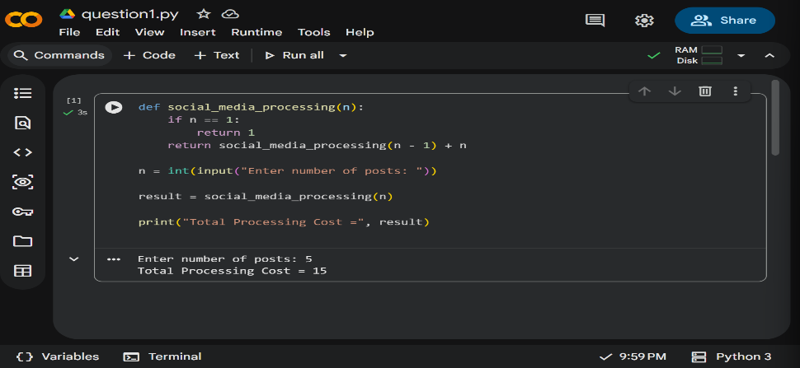
Substitution Method
Given:
$$T\left(n\right)=T\left(n-1\right)+n$$
Step 1
$$T\left(n\right)=T\left(n-2\right)+\left(n-1\right)+n$$
Step 2
$$=T\left(n-3\right)+\left(n-2\right)+\left(n-1\right)+n$$
Step 3
Continuing,
$$=T\left(n-k\right)+\sum_{i=n-k+1}^{n}{i}$$
When
$$n-k=1$$
then
$$k=n-1$$
Therefore,
$$T\left(n\right)=T\left(1\right)+2+3+⋯+n$$
Since
$$T\left(1\right)=1 \\ T\left(n\right)=1+\sum_{i=2}^{n}{i}$$
Using the formula
$$\sum_{i=1}^{n}{i}=\frac{n\left(n+1\right)}{2}$$
we obtain
$$T\left(n\right)=\frac{n\left(n+1\right)}{2}$$

Time Complexity
The recurrence expands through all values from n to 1. The total work performed is the sum of the first n natural numbers.
$$T\left(n\right)=Θ\left(n^{2}\right)$$
Time Complexity: Θ(n²)

Space Complexity
The recursive function stores one stack frame for each recursive call.
Maximum recursion depth = n
Therefore,
Space Complexity = Θ(n)

Asymptotic Notation
- Big-O: O(n²)
- Big-Theta: Θ(n²)
- Big-Omega: Ω(n²)

Analysis
The algorithm performs increasing work at every recursive call. Since the total work equals the sum of the first n natural numbers, the execution time grows quadratically. As the input size increases, the running time increases rapidly, making the algorithm less efficient for large datasets.

Conclusion
The recurrence relation was solved using the substitution method. The recursive implementation was verified through Python execution. The final asymptotic complexity is Θ(n²) with a space complexity of Θ(n).

